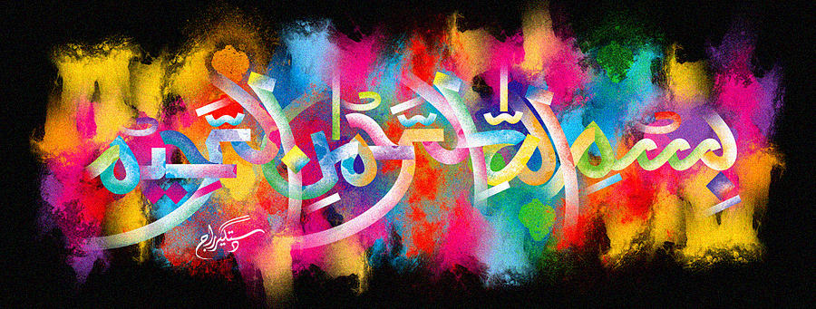
The Miracle South African Mandarins
Vol 2
The Exclusive Islamic Miracle Photographs of Dr Umar Elahi Azam
Wednesday 30th September 2015
Manchester, UK
Introduction
The name of Allah was revolving on the exterior surface of the peeled mandarin. I took 2 photographs and more were possible with the expenditure of extended time and greater effort. The Holy Name was also discovered on a sample slice of the mandarin. And, finally, Allah’s Name was also present on the inner peel. All fruits of this species always have markings of the Name of Allah in such places!
