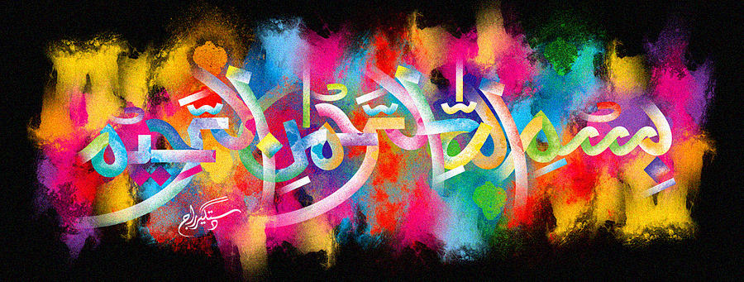
The Miracle Shortcake Biscuit
The Exclusive Islamic Miracle Photographs of Dr Umar Elahi Azam
Thursday 5th November 2015
Manchester, UK

Introduction
The Name of Allah was found in the cross-section of a Booker Happy Shopper-brand shortcake biscuit.
