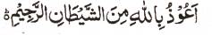

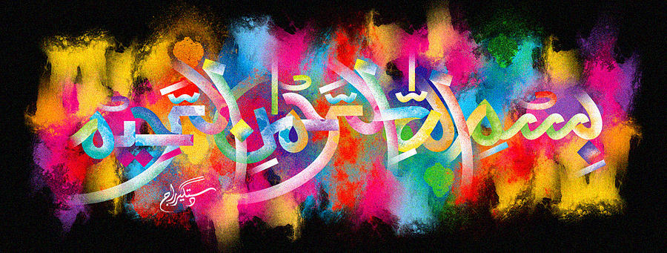
The Miracle Satsuma Leaf
The Exclusive Islamic Miracle Photographs of Dr Umar Elahi Azam
^{Sunday}6th December 2015
Manchester, UK

Introduction
The Name of Allah 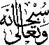 was found on a Satsuma leaf and it was vertically symmetrical, meaning the Holy Name could be read one way up and it could also be read the other way around! More impressions of the Holy Name could have been found as well but this is a specimen.
