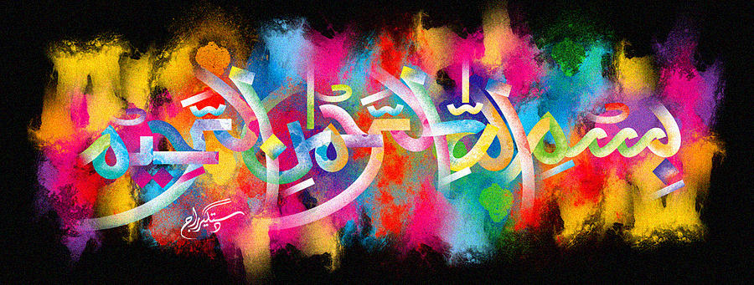
The Miracle Samosas of 9th October 2015
The Exclusive Islamic Miracle Photographs of Dr Umar Elahi Azam
Sunday 11th October 2015
Manchester, UK
Introduction
I accidentally held the camera lens of my Sony Xperia M2 Smartphone towards my tray of 2 samosas while transferring the photographs of the miracle apple from my Smartphone to my Gmail account. It was as if I was being told by Allah, “Look at the samosas for My Name!” I did so and, indeed, found one impression of The Name of Allah 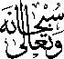 on one partially-eaten samosa and 2 impressions of the Holy Name on the complete samosa. On one impression (see the photograph on p. 9), the letter ‘Ha’ is very well developed.
