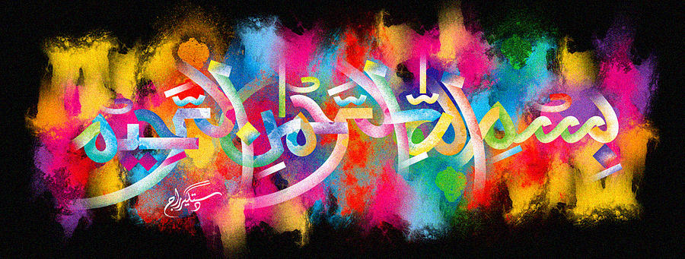
The Miracle Royal Gala Apple of 5th October 2015
The Exclusive Islamic Miracle Photographs of Dr Umar Elahi Azam
Monday 5nd October 2015
Manchester, UK
Introduction
The Name of Allah 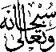 is made in the following way, in the centre of the apple, as shown by certain photographs below: look at the line running downwards through the pips – that is the Aliph. Now look at two small parallel semi-circular lines on either side of the seed – those are the two Lams. And the large curved line flowing downwards on the left is the letter Ha.
