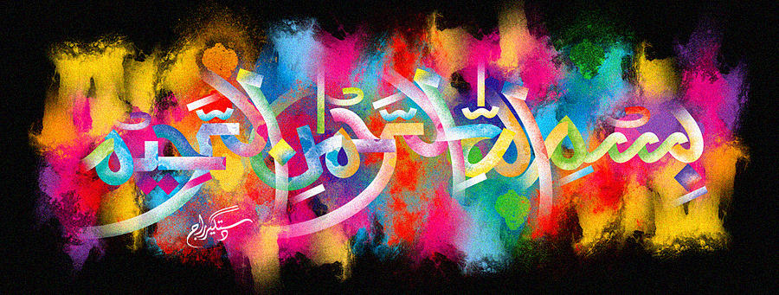
The Miracle Carrot of Friday 25th September 2015
Vol 1
The Exclusive Islamic Miracle Photographs of Dr Umar Elahi Azam
Sunday 27th September 2015
Manchester, UK
Introduction
i snapped the carrot in two and discovered that The Name of Allah 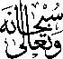 was on both cross-sections! in fact, there were more than one impression because the holy name was revolving ie one begins where another one finishes.
