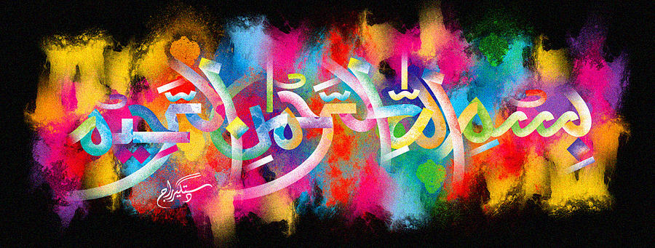
The Miracle Red Delicious Apples of Tuesday 29th September 2015
Vol 2
The Exclusive Islamic Miracle Photographs of Dr Umar Elahi Azam
Wednesday 30th September 2015
Manchester, UK
Introduction
there were 4 rotating markings of the name of Allah at the top of the red delicious apple – and finding even more was possible. a further two markings of the holy name were further down the apple.
