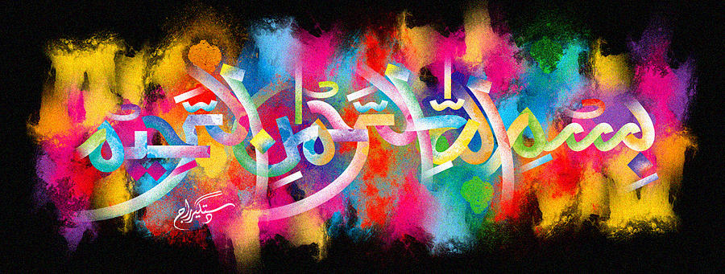
The Miracle Red Delicious Apple of Monday 28th September 2015
The Exclusive Islamic Miracle Photographs of Dr Umar Elahi Azam
Monday 28th September 2015
Manchester, UK
Introduction
there were clear marking of the name of Allah on a red delicious apple. i photographed one of the markings [the others would have been similar]. these apples were in a box of fruit [strawberries, peaches, apples and bananas] that my neighbour in whalley range, manchester uk, carlos, sold me for £4 today [monday 28th september 2015].
