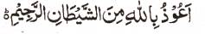

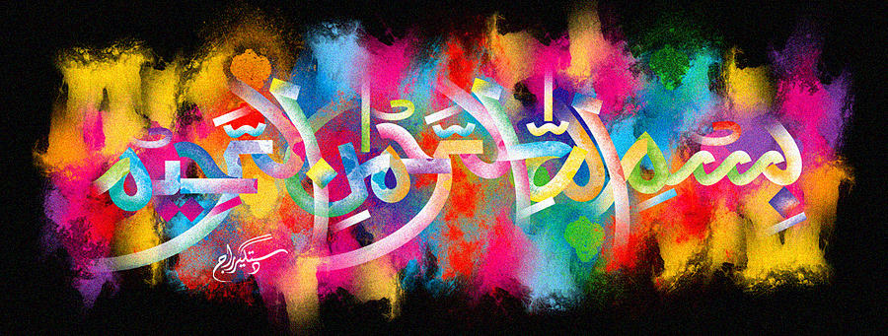
http://dr-umar-azam-islamicmiracles.weebly.com
Please see my Site, especially the RESEARCH section and sign my Guest Book with your unique comments.

THE MIRACLE HALAL PIZZA OF 26th DECEMBER 2015 – Vol 2
The Exclusive Islamic Miracle Photographs of Dr Umar Elahi Azam
^{Wednesday} 30th December 2015
Manchester, UK
INTRODUCTION
There were at least 2 impressions of the name of allah and one of Muhammad saw on this 7” pizza with toppings of anchovy, sweetcorn and pepperoni, bought from chesters take-away, Withington road, whalley range, Manchester , bought on 25th December.
