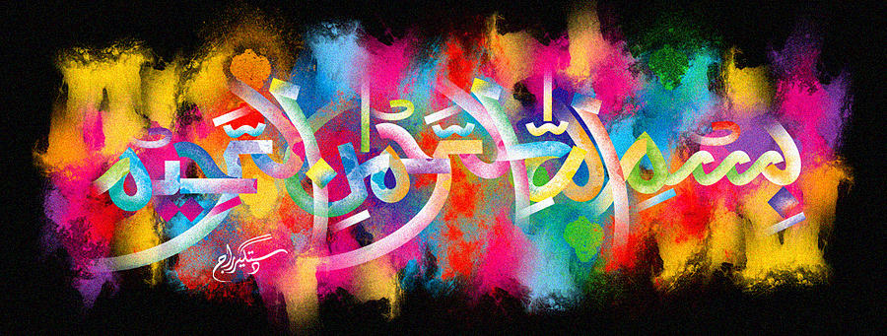
The Miracle Pink Jaffa Grapefruit 17th October 2015
Vol 3
The Exclusive Islamic Miracle Photographs of Dr Umar Elahi Azam
Saturday 17thOctober 2015
Manchester, UK

Introduction
The Name of Allah 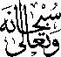 was everywhere on this pink Jaffa grapefruit – on the external surface, on the inner peel and on the slices themselves. It was possible to decipher dozens and dozens of markings of the Holy Name just on the slices, but I photographed just one slice as a sample.
