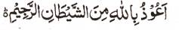

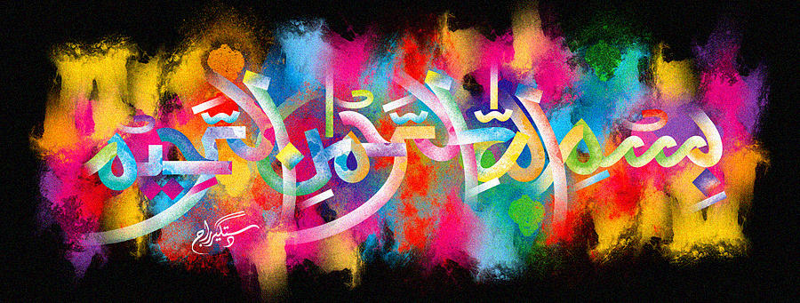
The Miracle Pineapple
The Exclusive Islamic Miracle Photographs of Dr Umar Elahi Azam
^{Friday 11th} December 2015
Manchester, UK

Introduction
There was one impressions of The Name of Allah 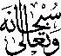 on the external surface and another in the cross-section. More markings were possible to locate. In two or three of the photographs below, a natural piece of the pineapple scalp which fell off after slicing seems to be pointing out the exact marking of the Name of Allah in the cross-section! This happened naturally and unexpectedly!
