http://www.quran-st.net/ELEMENTS%20OF%20NAMAZ_files/image008.jpg



**The Miracle Persimmon-Vol 2**

***T*he Exclusive Islamic Miracle Photographs of Dr Umar Elahi Azam**

**Sunday 15th November 2015**

***M*anchester, UK**

**Introduction**

**The Name of Allah**  **was on the external surface, on an internal blemish, in the interior and in the cross-section of this persimmon. The name of Muhammad 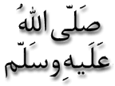was in the interior of this fruit too.**

PicturePicturePicturePicture

