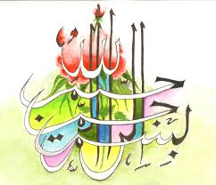
The Miracle Pear of Thursday 24th September 2015 [The Day of Eid ul-Adha]
Vol 2
The Exclusive Islamic Miracle Photographs of Dr Umar Elahi Azam
Thursday 24th September 2015
Manchester, UK
Introduction
There were two markings of The Name of Allah 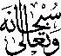 on the surface. And there was a very unusual marking that depicts both Allah and Muhammad 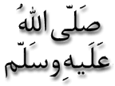 depending on how you look at it. This has never before happened on any of the fruits or vegetables in this Research section of my Site: http://dr-umar-azam-islamicmiracles.weebly.com The photography took place between c. 2:00 am and 3:00 am in my Yarburgh Street, Whalley Range, Manchester UK lodgings.
