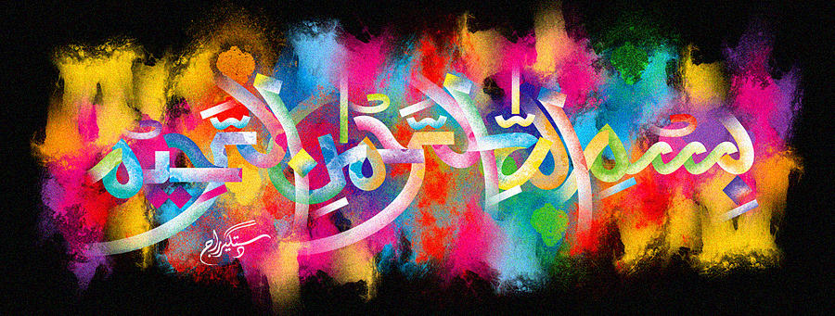
The Miracle Peach of Tuesday 29th September 2015
Vol 2
The Exclusive Islamic Miracle Photographs of Dr Umar Elahi Azam
Tuesday 29th September 2015
Manchester, UK
Introduction
there were 4 markings of the name of allah 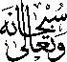 on the exterior surface of this large peach. i think even more markings of the holy name were present and may have been found with a magnifying glass of high resolution which i doid not have. i shaded the side of each marking with a small inky patch to keep track of which particular marking had already been photographed. these peaches were in a box of fruit [strawberries, peaches, apples and bananas] that my neighbour in whalley range, manchester uk, carlos, sold me for £4 on monday 28th september 2015.
