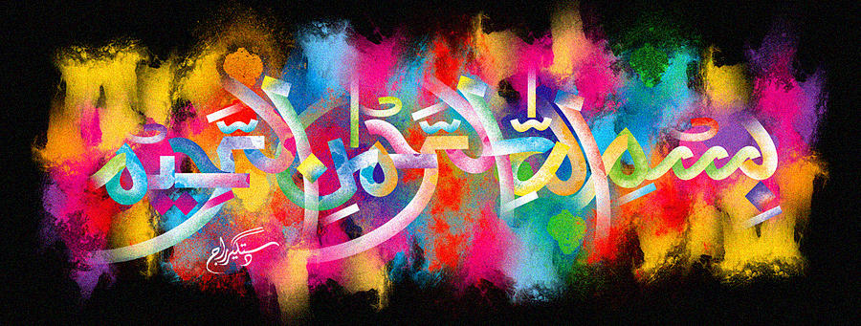
The Miracle Peach of Thursday 1st October 2015
Vol 2
The Exclusive Islamic Miracle Photographs of Dr Umar Elahi Azam
Thursday 1st October 2015
Manchester, UK
Introduction
The name of Allah 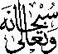 was found in the following places on this peach:
[a] on the exterior surface
[b] on the interior surface
[c] on the see [the stone]; there were 2 separate impressions of the Holy Name on the seed
These markings were found at 1:30 am
