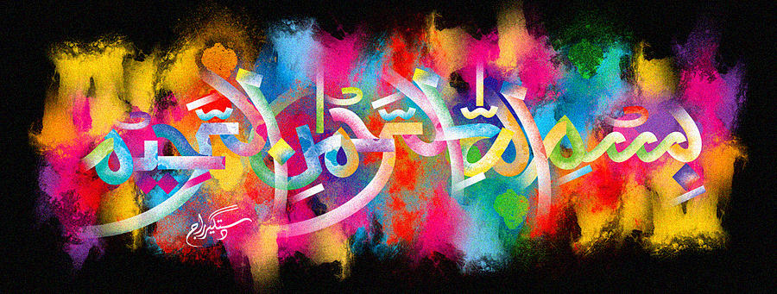
The Miracle Peach of Monday 28th September 2015
Vol 1
The Exclusive Islamic Miracle Photographs of Dr Umar Elahi Azam
Monday 28th September 2015
Manchester, UK
Introduction
there were two clear marking of the name of Allah on a large, fresh crispy, tangy peach: on the the exterior surface and one in the interior of the peach. the exterior marking of the holy name was found later. this peach was in a box of fruit [strawberries, peaches, apples and bananas] that my neighbour in whalley range, manchester uk, carlos, sold me for £4 today [monday 28th september 2015].
