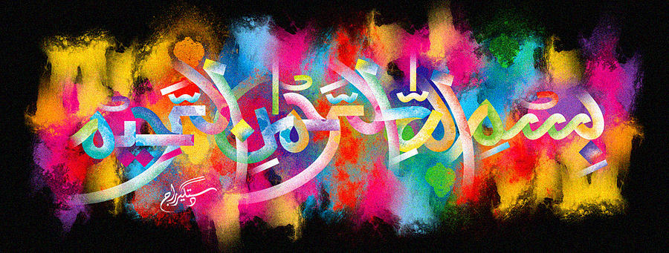
The Miracle Peach of Friday 2nd October 2015
Vol 2
The Exclusive Islamic Miracle Photographs of Dr Umar Elahi Azam
Saturday 3rd October 2015
Manchester, UK
Introduction
There were 2 impressions ofThe name of Allah 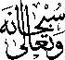 in the cross-sections of two quarters of this peach, as well as on the red peripheral area around the seed and on the seed itself.
