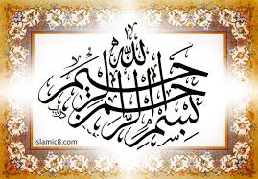
The Miracle Orange of 30th August 2015
Vol. 1
The Exclusive Islamic Miracle Photographs of Dr Umar Elahi Azam
Sunday 3oth August 2015
Manchester, UK

Introduction
The Name of Allah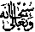was made in the centre of the orange by its white strands and natural impressions on the orange itself. The Name of Allah was also formed on the very flesh of the fruit itself in two places. This orange was one of the small oranges from MRF No 159 in the Research section of: http://dr-umar-azam-islamicmiracles.weebly.com
