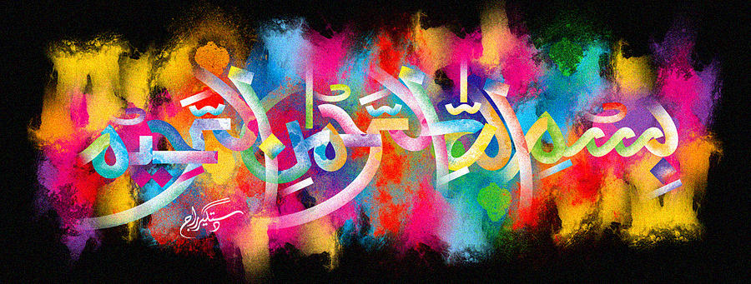
The Miracle Orange of 11th October 2015
The Exclusive Islamic Miracle Photographs of Dr Umar Elahi Azam
Sunday 11th October 2015
Manchester, UK
Introduction
The Name of Allah was clearly marked on the external surface of this orange, (centre-top).
