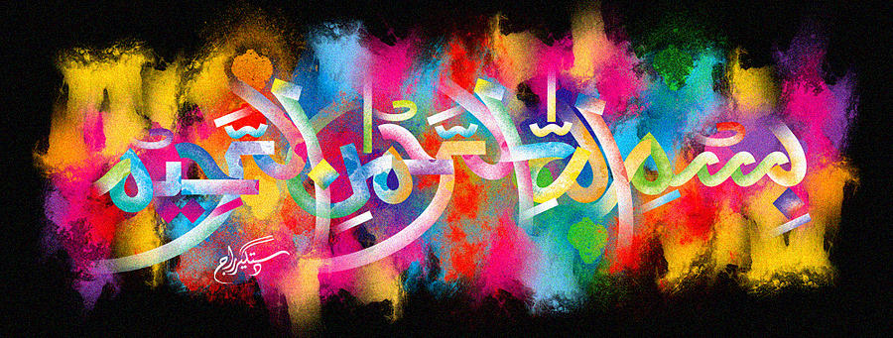
The Miracle Orange Halwa Lid
The Exclusive Islamic Miracle Photographs of Dr Umar Elahi Azam
^{Wednesday 28th}October 2015
Manchester, UK

Introduction
The Name of Allah was discovered on the lid of my portion of orange halwa [semolina pudding] bought with the dahi bhale chana chaat portion from Sanam Restaurant, Stockport Road, Longsight, Manchester UK on Monday 26th October 2015.

