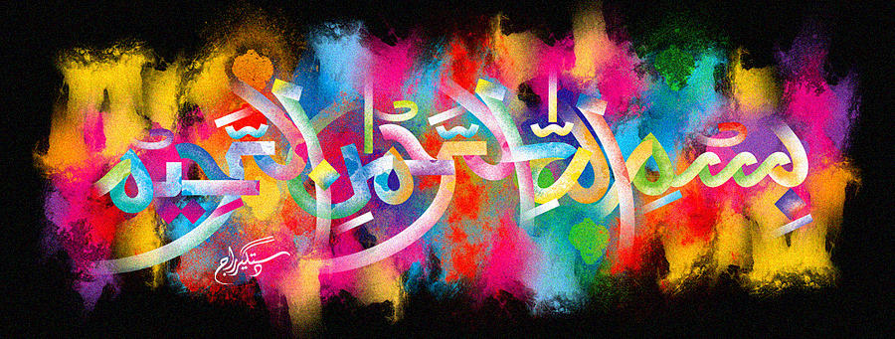
The Miracle Onion of Monday 28th September 2015
The Exclusive Islamic Miracle Photographs of Dr Umar Elahi Azam
Monday 28th September 2015
Manchester, UK
Introduction
the name of Allah 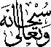 can be seen clearly formed inside the onion. i was going to make a cheese and onion sandwich using the slices of this onion when i noticed the name of allah in the croos-section!
