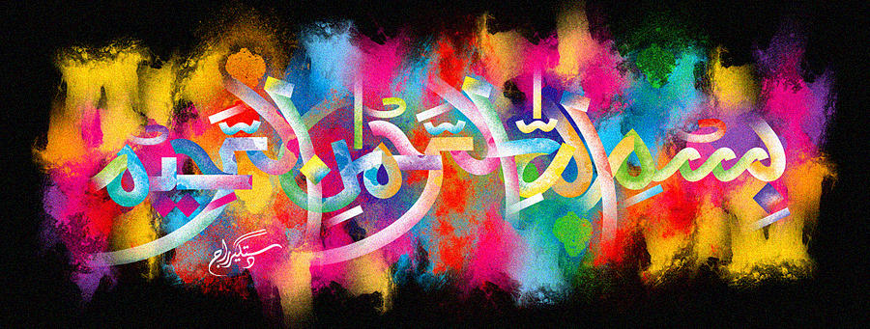
The Miracle of the Ink Forming the Name of Allah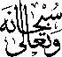 on My Hand on Friday 2nd October 2015
The Exclusive Islamic Miracle Photographs of Dr Umar Elahi Azam
Friday 2nd October 2015
Manchester, UK
Introduction
I was tutoring [Ilsa, aged 9] a maths tuition lesson today in Longsight, Manchester, UK and tried to use a brand new black ballpoint pen. But the ink had leaked backwards while the pen was in my pocket, with the result that, when I took the refill out of its barrel to inspect the problem, much of the ink was transferred onto my left hand as I held the refill in my right hand. I got a pleasant surprise when I noticed that some of the ‘spilt’ ink had formed The name of Allah on the Mount of Venus section under my left thumb!
