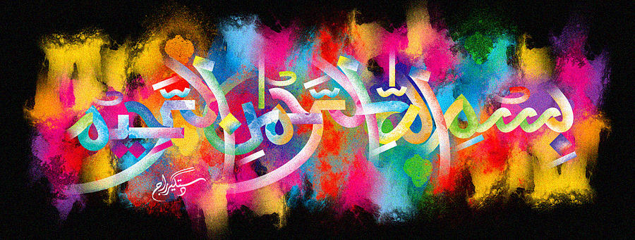
The Miracle Oaklands British Apples of 5th October 2015
Vol 4
The Exclusive Islamic Miracle Photographs of Dr Umar Elahi Azam
Tuesday 6th October 2015
Manchester, UK
Introduction
These apples were bought, amongst other fruit, from the Lidl Store on Stockport Road, Manchester 13 UK on Monday 5th October. There were 10 apples in the bag and each had at least one impression of The Name of Allah on it; some apples had 2, 3 or even 4 [revolving shape of the Holy Name] impressions on them.
