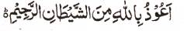

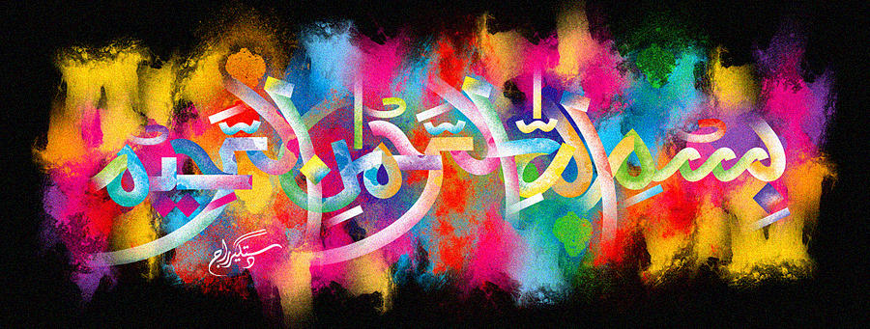
The Miracle Naan of Friday 11th December 2015
The Exclusive Islamic Miracle Photographs of Dr Umar Elahi Azam
^{Friday 11th} December 2015
Manchester, UK

Introduction
I ordered a chicken-and-spinach curry and one naan from Taj K2 take-away, Hamilton Road, Longsight, Manchester UK and noticed that there were 2 impressions of The Name of Allah 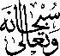 on the naan! In the first impression, the letter ‘Ha’ is prominent, whereas in the second, the letter ‘Aliph’ is the leading letter.
