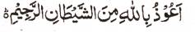

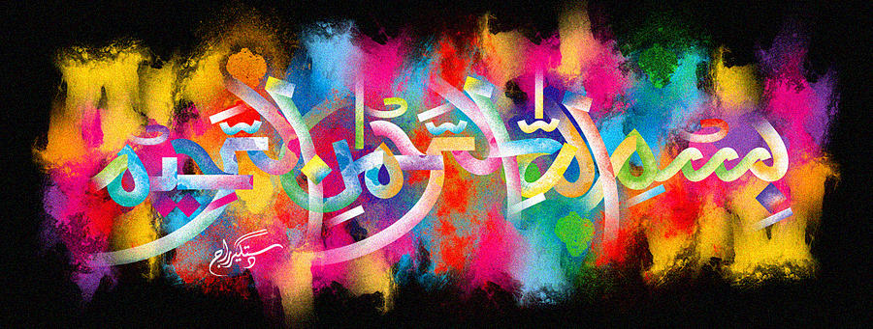
The Miracle Naan of 19 November 2015 – Vol 2
The Exclusive Islamic Miracle Photographs of Dr Umar Elahi Azam
^{Saturday} 21st November 2015
Manchester, UK

Introduction
The Name of Allah 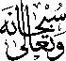 was found in 3 places on this single naan! The naan was part of a donner kebab meal bought from Camel One take-away on Wilmslow Road, Manchester UK.
