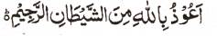

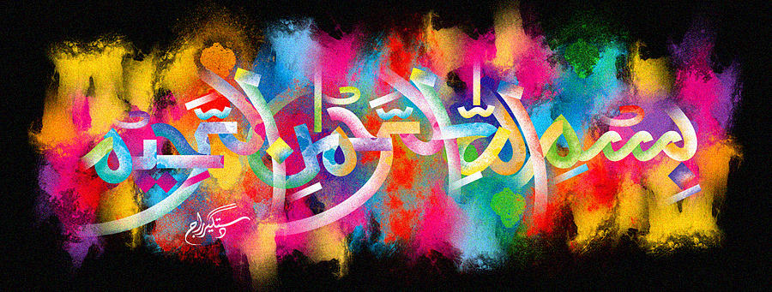
The Miracle Naan of 16-12-15
The Exclusive Islamic Miracle Photographs of Dr Umar Elahi Azam
^{Wednesday} 16th December 2015
Manchester, UK

Introduction
There were 3 impressions of The Name of Allah 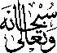 on this naan [and there seems to be a double impression on one of the three markings!] which was part of a medium seekh kebab meal that I bought from the Paan House Restaurant and Take-Away, Old Trafford, Manchester UK on the date of this Paper. I dined in-house and took these photographs part-way through my meal with fellow diners and waiting customers watching what I was doing curiously!
