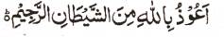

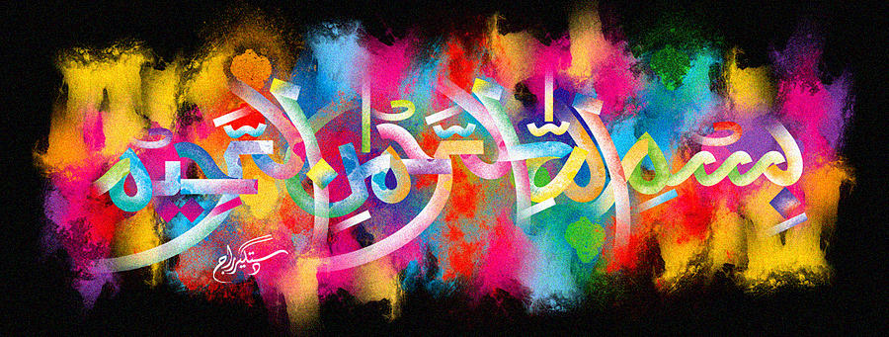
http://dr-umar-azam-islamicmiracles.weebly.com
Please see my Site, especially the RESEARCH section and sign my Guest Book with your unique comments.

THE MIRACLE MORSEL OF HALAL LAMB [B]
The Exclusive Islamic Miracle Photographs of Dr Umar Elahi Azam
^{SATURDAY} 2 JANUARY 2016
Manchester, UK
Although these photographs belong to Dr Umar Azam, readers have permission to use any/all of the photographs as long as the source is acknowledged. Miracle Photographs, for example, have been shared on Twitter in the recent past.

The Name of Allah 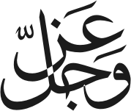 was in the cross-section of the halal meat, most probably leg of lamb, part of a nihari meal that I bought from Sanam Restaurant, Stockport Road, Manchester UK on the 31st December 2015. The photographs below are of the second morsel.
What is nehari? Please see:
http://www.wikihow.com/Make-Nihari
