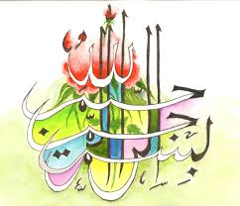
The Miracle Mooli of Thursday 24th September 2015 [The Day of Eid ul-Adha]
Vol 3
The Exclusive Islamic Miracle Photographs of Dr Umar Elahi Azam
Thursday 24th September 2015
Manchester, UK
Introduction
Two markings of The Name of Allah 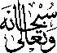 were found on the outside surface of the mooli [white radish]. Two further markings of the Holy Name were in the inner surface [after I had almost given up hope of finding a marking after several minutes of searching]. Because of camouflage difficulties, to find even more markings, I smeared the external natural markings of the mooli with a solution of instant coffee and water to highlight the lines but was still unable to find a third external marking of the Name of Allah as the lines were still feint.
