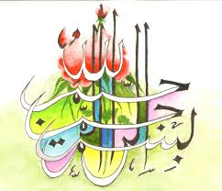

**The Miracle Mooli of Thursday 24th September 2015 [The Day of Eid ul-Adha]**

**Vol 2**

***T*he Exclusive Islamic Miracle Photographs of Dr Umar Elahi Azam**

***T*hursday 24th  September 2015**

***M*anchester, UK**

**Introduction**

**Two markings of The Name of Allah  were found on the outside surface of the mooli [white radish]. Two further markings of the Holy Name were in the inner surface [after I had almost given up hope of finding a marking after several minutes of searching]. Because of camouflage difficulties, to find even more markings, I smeared the external natural markings of the mooli with a solution of instant coffee and water to highlight the lines but was still unable to find a *third* external marking of the Name of Allah  as the lines were *still* feint.**

Picture Picture PicturePicture

