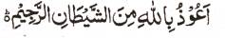

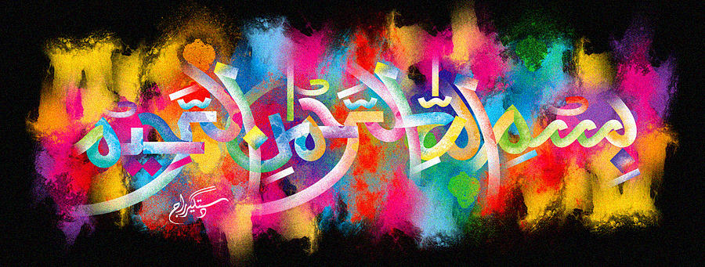
T he Miracle Mandarin of Tuesday 15/12/15
The Exclusive Islamic Miracle Photographs of Dr Umar Elahi Azam
^{Tuesday} 15th November 2015
Manchester, UK

Introduction
One impression of The Name of Allah 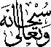 was naturally formed on the external surface of this mandarin.
