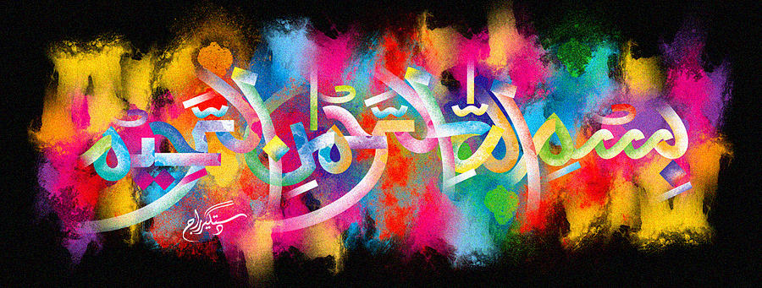
The Miracle Lamb Shoulder Bones – Vol 1
The Exclusive Islamic Miracle Photographs of Dr Umar Elahi Azam
Monday 19thOctober 2015
Manchester, UK

Introduction
I bought a lamb and potato cyrry from Taj K2 Take-Away, Hamilton Road, Manchester 13 UK on Saturday 17th October. 3 impressions of The Name of Allah 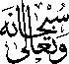 were on 2 lamb shoulder bones:
1st bone ……2 markings of the Holy Name on the same side of the bone
2nd bone…..1 definite marking and other markings also possibly present on one side of the bone
