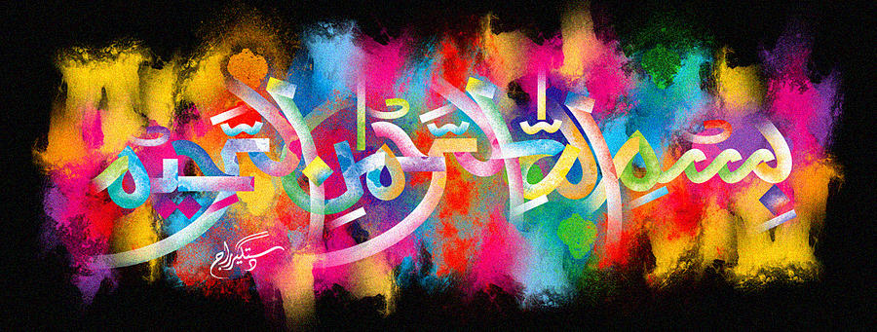
The Miracle Lamb Bone of 8th November 2015
The Exclusive Islamic Miracle Photographs of Dr Umar Elahi Azam
Monday 9th November 2015
Manchester, UK

Introduction
I bought a meat and potato curry from Spice Kitchen on Wilmslow Road, Manchester 14 UK and it was a pleasant surprise to find the Name of Allah 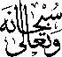 on one of the lamb bones.
