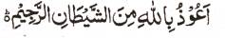

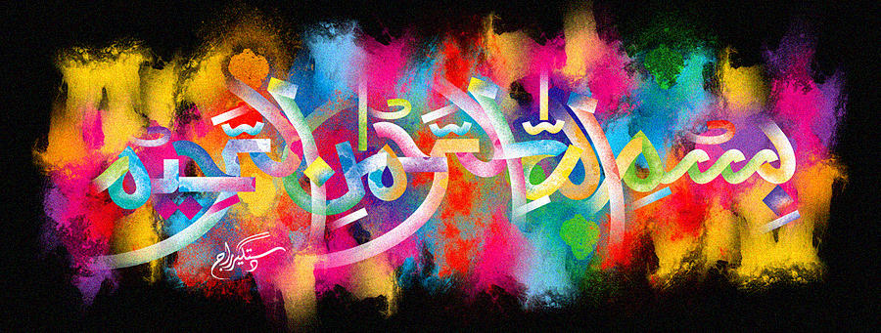
The Miracle Jalebi
The Exclusive Islamic Miracle Photographs of Dr Umar Elahi Azam
^{Thursday} 17th December 2015
Manchester, UK

Introduction
A jalebi naturally formed The Name of Allah but I only managed to take two photographs before the piece broke up! The freshly-prepared jalebis had been bought from Sanam Banqueting Hall & Restaurant, Stockport Road, Manchester , UK only a few hours before the taking of the photographs.
From Wikipedia, the free encyclopedia

Jalebi
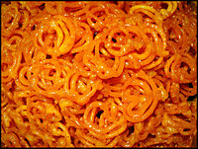
Jalebis as served in India
Alternative names | Jilbi, Jilipi, Jilapi, Zelapi, Jilapir Pak, Jilebi (India), Jilawii, Zoolbia (Middle East), Jeri (Nepal), Z'labia (Tunisia)
Course | Dessert
Place of origin | Multiple
Region or state | Middle East, South Asia, East Africa, Philippines (selling inErmita)
Serving temperature | Hot/Cold
Main ingredients | Maida flour, saffron, ghee,sugar
Variations | Jahangiri or Imarti
Cookbook: Jalebi Media: Jalebi
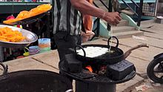
Jalebi being prepared in a roadside shop in Bangalore
Jalebi, also known as Zulbia, is a sweet popular in countries of South Asia, the Middle East, North Africa (except Morocco) and East Africa. It is made by deep-frying a wheat flour (maida flour) batter in pretzel or circular shapes, which are then soaked in sugar syrup. They are particularly popular in South Asia during Ramadan and Diwali.
The sweets are served warm or cold. They have a somewhat chewy texture with a crystallized sugary exterior coating. Citric acid or lime juice is sometimes added to the syrup, as well as rose water. Jalebi is eaten with curd, rabri (North India) along with optional other flavours such as kewra (scented water).
This dish is not to be confused with similar sweets and variants like imarti and chhena jalebi.
