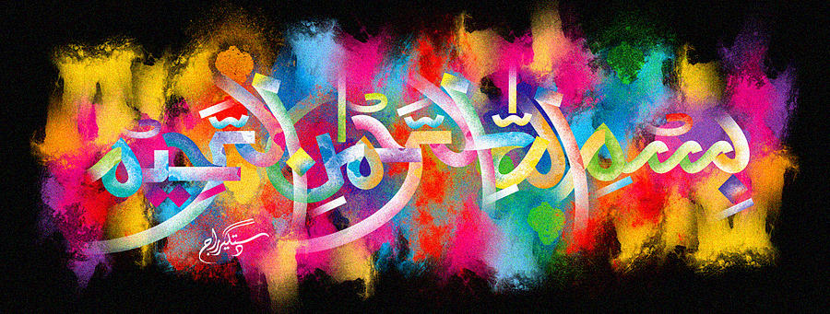
The Miracle Jaffa Orange of 11th November 2015- Vol 2
The Exclusive Islamic Miracle Photographs of Dr Umar Elahi Azam
Wednesday 11th November 2015
Manchester, UK

Introduction
There were many impressions of The Name of Allah 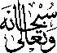 made by the pith and the cross-section of this orange.
