

**The Miracle Honeydew Melon of Tuesday 13th October 2015**

**Vol 2**

***T*he Exclusive Islamic Miracle Photographs of Dr Umar Elahi Azam**

***Tuesday* 13th October 2015**

***M*anchester, UK**

**Introduction**

**This honeydew melon had one impression of Muhammad 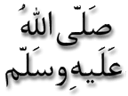 and 4 impressions of the Name of Allah**  **on its external surface and *one* impression of the Name of Allah on its internal surface.**

Picture PicturePicturePicture

