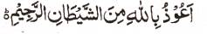

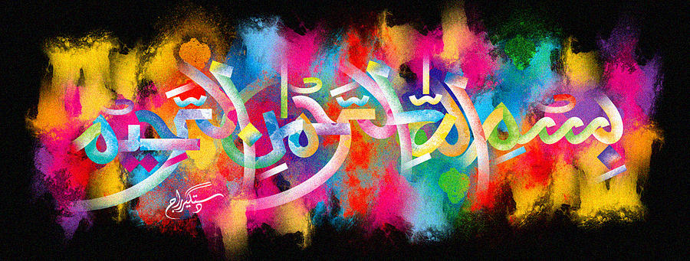
The Miracle Honeydew Melon of 12/11/15- Vol 2
The Exclusive Islamic Miracle Photographs of Dr Umar Elahi Azam
^{Sunday 15th} November 2015
Manchester, UK

Introduction
There were 2 large impressions of The Name of Allah 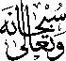 on the external surface of this melon.
