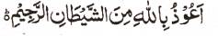

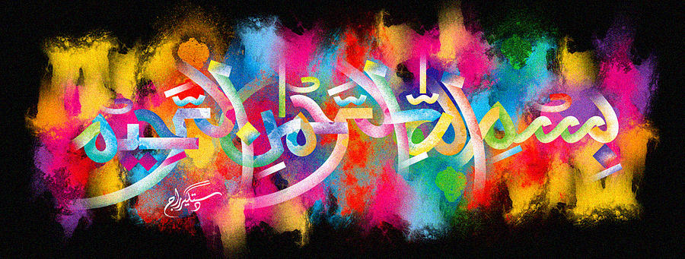
The Miracle Galia Melon of ^{6th} December 2015 – Vol 2
The Exclusive Islamic Miracle Photographs of Dr Umar Elahi Azam
^{Sunday}6th December 2015
Manchester, UK

Introduction
There were 3 impressions of the Name of Allah 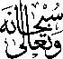 on the external surface, 0ne impression formed by my bite marks and one impression formed by the seeds.
