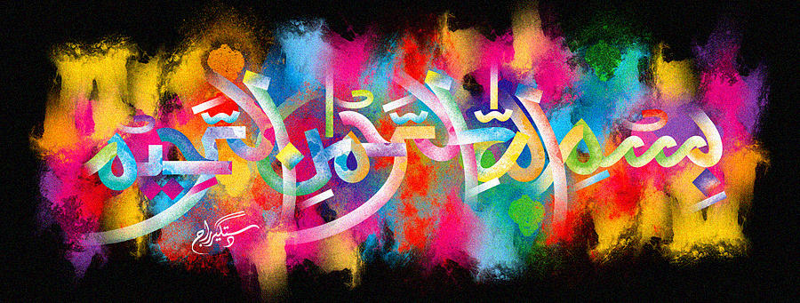
The Miracle Fun Size Pears of 5th October 2015
Vol 1
The Exclusive Islamic Miracle Photographs of Dr Umar Elahi Azam
Tuesday 6th October 2015
Manchester, UK
Introduction
These pears were bought, amongst other fruit, from the Lidl Store on Stockport Road, Manchester 13 UK on Monday 5th October. There were 9 pears in the bag. This fruit is a record-breaking fruit, containing the most Islamic markings of any fruit or fruits photographed for the Files in the Research section of http://dr-umar-azam-islamicmiracles.weebly.com Most markings were photographed just once. The following markings were found, recorded in the order of their discovery:
Pear 1 A A A
Pear 2 A
Pear 3 A A
Pear 4 A M M M M A A UAr A
Pear 5 A UAr
Pear 6 M A M A M
Pear 7 A A M
Pear 8 M A M A
Pear 9 A M M A M M A A A
---------------------------------------------------------------------------
A = Allah SWT
M = Muhammad SAW
UAr = Unidentified Arabic
