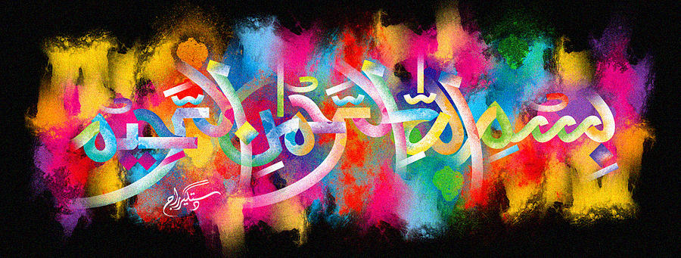
The Miracle Fairtrade Bananas of Wednesday 14th October 2015
Vol 2
The Exclusive Islamic Miracle Photographs of Dr Umar Elahi Azam
Wednesday 14thOctober 2015
Manchester, UK
Introduction
The first banana had The Name of Allah 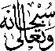 on it in 3 places: on the outer peel, on a ripe part of the fruit itself and on the inner peel, The second banana had a formation of the Holy Name on its stem.
