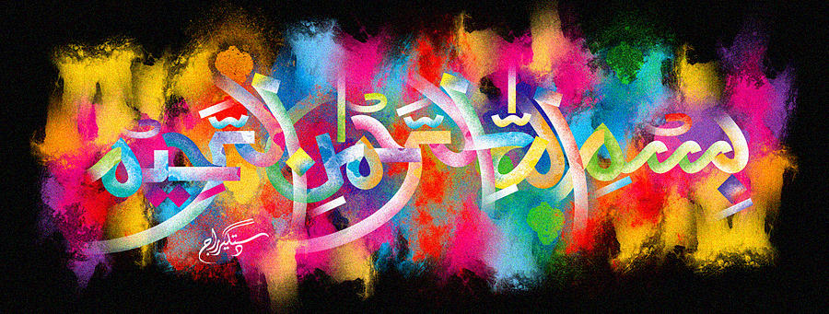
The Miracle Fairtrade Bananas: The Pack
Vol 3
The Exclusive Islamic Miracle Photographs of Dr Umar Elahi Azam
Wednesday 7th October 2015
Manchester, UK
Introduction
