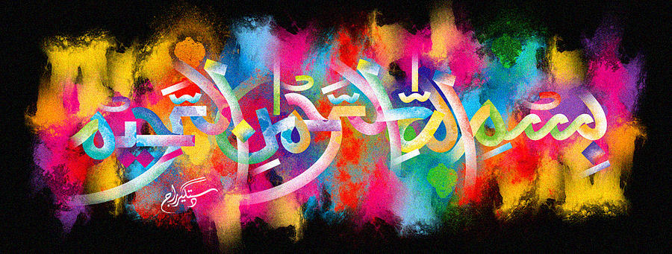
THE MIRACLE DOLE BANANA 2
Vol 2
The Exclusive Islamic Miracle Photographs of Dr Umar Elahi Azam
Friday 2nd October 2015
Manchester, UK
Introduction
There were impressions of The name of Allah 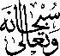 in numerous places on this banana: on the ‘crown’, on the inner peel and behind the epicarp, mesocarp and endocarp combined; that is to say, on the inside of the black knob at the bottom of the banana.

