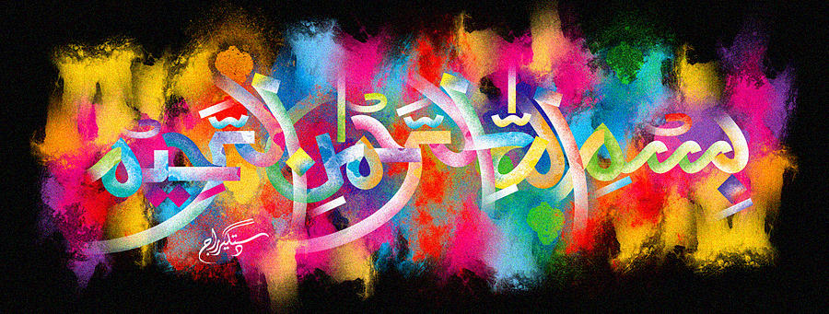
The Miracle Carrot of Sunday 27th September 2015
The Exclusive Islamic Miracle Photographs of Dr Umar Elahi Azam
Sunday 27th September 2015
Manchester, UK
Introduction
the name of Allah 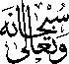 can be seen clearly formed on the end of a carrot. another piece was first sliced vertically and then sliced diagonally to reveal another marking of the holy name.
