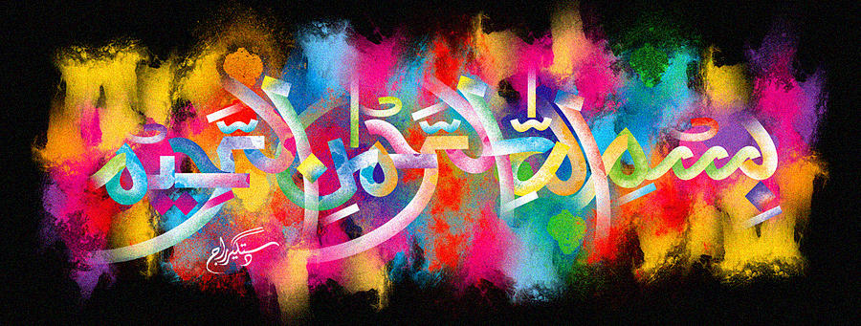
The Miracle Cucumber of 15th October 2015
The Exclusive Islamic Miracle Photographs of Dr Umar Elahi Azam
Thurssday 15thOctober 2015
Islamic New Year Muharram 1437 A.H.
Manchester, UK
Introduction
The Name of Allah was formed in the seed compartment of this cucumber and, in fact, more than one impression of the Holy Name may be deciphered in the pattern.
