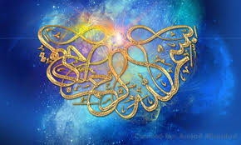
ALLAH’S 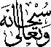 NAME AND THE NAME OF MUHAMMAD 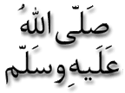ON 3 CONFERENCE PEARS
Vol 2
The Exclusive Islamic Miracle Photographs of Dr Umar Elahi Azam
Tuesday 3rd September 2015
Manchester, UK

Introduction
The Name of Allah and that of Muhammad were on the surface of the conference pears that were bought, amongst other fruit and vegetables, from Manchester Superstores, Stockport Road, Manchester UK on Monday 31st August.
