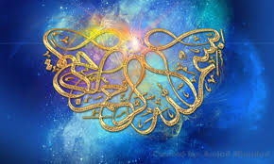

**ALLAH’S  NAME AND THE NAME OF MUHAMMAD 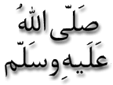ON 3 CONFERENCE PEARS**

**Vol 1**

***T*he Exclusive Islamic Miracle Photographs of Dr Umar Elahi Azam**

**Tuesday 3rd September 2015**

***M*anchester, UK**

**Introduction**

**The Name of Allah  and that of Muhammad  were on the surface of the conference pears that were bought, amongst other fruit and vegetables, from *Manchester Superstores*, Stockport Road, Manchester UK on Monday 31st August.**

Picture Picture PicturePicture

