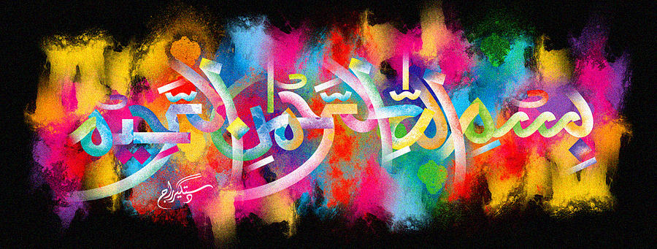
The Miracle Chilean Ndorcott
The Exclusive Islamic Miracle Photographs of Dr Umar Elahi Azam
Thursday 8th October 2015
Manchester, UK
Introduction
The Name of Allah 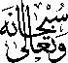 was on the exterior surface of this peeled Chilean nadorcott (mandarin). All nadorcotts have identical markings and, indeed, the other ones that I had consumed also had the Name of Allah in them. But to have photographed many more of the same markings would have meant repeating this paper over and over.
