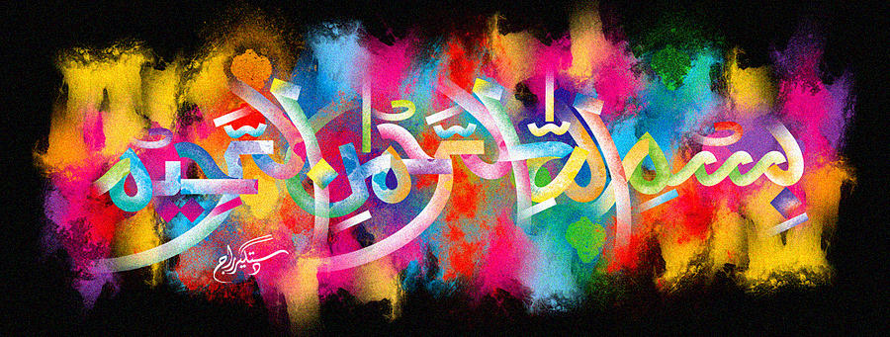
The Miracle British Plums of 7th October 2015
Vol 2
The Exclusive Islamic Miracle Photographs of Dr Umar Elahi Azam
Wednesday 7th October 2015
Manchester, UK
Introduction
The plums had the following markings:
Plum 1 ……. Muhammad SAW
Plum 2 …….Allah SWT
Plum 3 …….. Muhammad SAW
Plum 4 ……..Allah SWT
And one of the plums had an impression of the Name of Allah 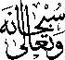 in its cross-section too.
