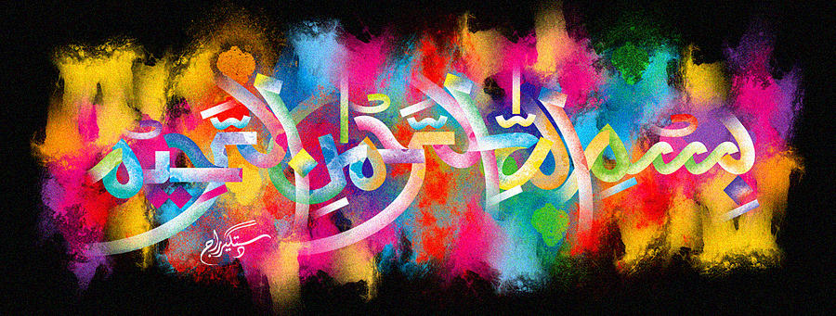
The Miracle Bananas of Tuesday 29th September 2015
Vol 4
The Exclusive Islamic Miracle Photographs of Dr Umar Elahi Azam
Tuesday 29th September 2015
Manchester, UK
Introduction
there were 15 islamic markings on 7 bananas, 14 of the name of Allah 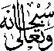 and one of the name of muhammad 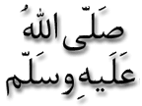 these bananas were in a box of fruit [strawberries, peaches, apples and bananas] that my neighbour in whalley range, manchester uk, carlos, sold me for £4 today [monday 28th september 2015]. they were in the following sequence:
Banana | brand | marking
1 | chiquita | a | a
2 | chiquita | a
3 | ? | a | a | both markings highlighted in ink
4 | chiquita | m | a on the stem
5 | chiquita | a | a
6 | chiquita | A | A on the stem
7 | chiquita | A | A | A on the stem
A = NAME OF ALLAH
M = NAME OF MUHAMMAD

