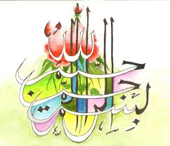
The Miracle Bananas of Sunday 20th September 2015
Vol 1
The Exclusive Islamic Miracle Photographs of Dr Umar Elahi Azam
Monnday 21st September 2015
Manchester, UK
Introduction
The Name of Allah 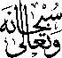 and the name of Muhammad 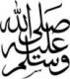was on the exterior surfaces of three bananas in the following sequence:
Banana
1 | M | A | A
2 | M | A – The Name of Allah was going around the stem of the banana, so it was difficult to photograph the 3-dimensional view | A
3 | -
4 | A

