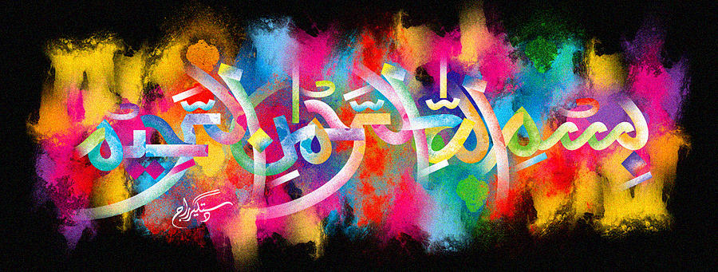
The Miracle Bananas of 20 October 2015- Vol 2
The Exclusive Islamic Miracle Photographs of Dr Umar Elahi Azam
Tuesday 20th October 2015
Manchester, UK

Introduction
There were 5 impressions of The Name of Allah 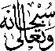 on 4 bananas in the following sequence:
Banana 1 ….External Surface & Crown
Banana 2 …..Crown
Banana 3 ….. Crown
Banana 4 ….. The name of Muhammad 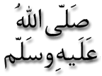in the cross-section & the Name of Allah on the inner peel [all bananas have multiple markings of the Name of Allah in this place!] & at the very top of the crown.
